Software Design Specification

Class Name
Class Code
Group
Teacher
Project Manager
Assign Date
Complete Date
Author
Version
Approved By
Approved Date

Table of Contents

1. Introduction 3
1.1 Purpose 3
1.2 Scope 3
1.3 Definitions, Acronyms and Abbreviations 3
1.4 References 3
2. Hight Level Design 4
2.1 Design Considerations 4
2.1.1 Design Options 4
2.1.2 Assumptions 4
2.1.3 Constraints 4
2.2 System Level Desired Behavior 4
2.3 Logical Representation of the Architecture 5
2.4 Architectural Component Overview 5
2.4.1 Software Dependencies 6
2.4.2 Party Component Description 6
2.5 Process Architecture 6
2.6 Deployment Architecture 7
3. Detailed Design (Component Design) 8
3.1 Component/Feature: <Component/Feature #1 (Use the name)> 8
3.1.1 Object Model 8
3.1.2 Scenarios 8
3.1.3 Class Summary 9
3.1.3.1 Class: <Class#1 (Use the class name)> 9
3.1.4 Algorithms 10
3.1.5 Interfaces 10
3.1.6 Dependencies 10
3.1.7 Error Handling 10
3.1.8 GUI Mockups 10
4. Open Issues 11

Introduction

Purpose
<Provide a brief summary indicating the purpose, scope and use of this document.>

Scope
<Describe the boundaries of the design here. State what functionality is included and what is excluded. This statement is given in terms of business functions.>

Definitions, Acronyms and Abbreviations
<This section includes terms, acronyms and abbreviations herein>

References
<The following references are cited in this document:
- [SRS] Please refer to the latest approved version of the document <Put SRS title here>. <Please provide the hyperlink to the library containing this SRS for the SRS title>
- [RTM] Please refer to the latest approved version of the document. RTM can be use to trace all requirements related to the component.<Put RTM title here>. <Please provide the hyperlink to the library containing this RTM for the RTM title>
(Optional) – Note any references or related materials here.(Some other technical documents like: IETF, RFC… that you mentioned above.)>

Hight Level Design

Design Considerations // yêu cầu phi chức năng
In this section, consider high-level design options. Consider non-functional (product or technology) requirements which push your design in a specific direction.

Design Options //Hướng thiết kế
At a high-level, describe the design direction and rationale. Also, describe alternative approaches considered and rationale for them not being chosen.

Assumptions //Giả định, đặt vấn đề cần/nên được giải quyết
Document the assumptions, open issues, concerns that guide the design or have the possibility of affecting the design.
Open issues should be addressed before the design is completed. If assumptions are invalidated or change, the design must be revisited to ensure design changes are made as necessary.

Constraints //Hạn chế/ràng buộc giới hạn phần mềm
Indicate the constraints that affect the design, i.e. restrictions imposed on the design that force the design decisions a certain way. Once again, this is driven by non-functional requirements, such as real-time, memory, reliability, scalability etc.

System Level Desired Behavior
This is equivalent to the Scenario View as per the 4+1 model.
At the very highest level, describe how the requirements will be shown at the system level. If the design involves messaging or similar behavior, a basic overview would be a good idea.
If you are using an object oriented design methodology, document key Use Cases which describe how the hardware modules or nodes work together to satisfy the feature requirements.
Diagrams are highly recommended.
Sample:
This sample shows a fragment of a scenario for the small PABX. The corresponding script reads:
1. The controller of Joe’s phone detects and validate the transition from on-hook to off-hook and sends a
message to wake up the corresponding terminal object.
2. The terminal allocates some resources, and tells the controller to emit some dial-tone.
3. The controller receives digits and transmits them to the terminal.
4. The terminal uses the numbering plan to analyze the digit flow.
5. When a valid sequence of digits has been entered, the terminal opens a conversation.
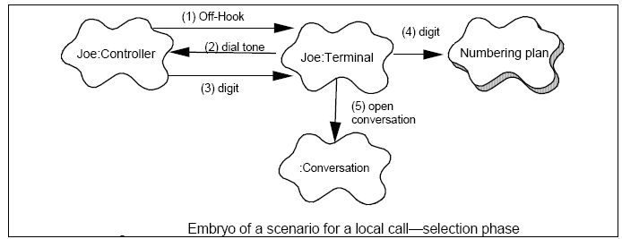

Logical Representation of the Architecture
This is equivalent to the Logical View as per the 4+1 model.
At the very highest level, describe a logical representation of the architecture that will be used to satisfy the functional requirements. This representation is not constrained by existing software architectures, product requirements or target hardware platforms upon which the functional requirements will be satisfied.
Sample:
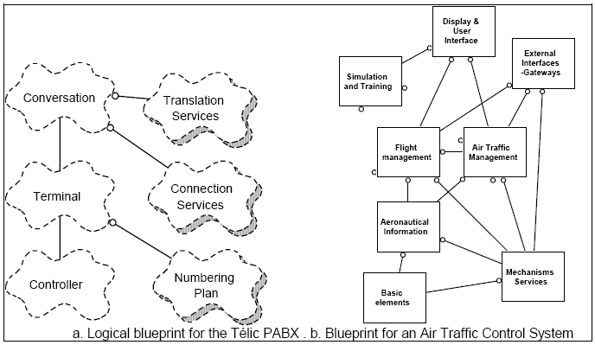

Architectural Component Overview
This is equivalent to the Implementation View as per the 4+1 model.
Identify and describe the software components that make up the architecture and their relationships.. Identify new, changed, and if applicable, deleted software components required to satisfy the functional requirements.
It is important to take into account non-functional requirements (such as real-time, redundancy etc.) when describing the architecture at this level.
Sample:
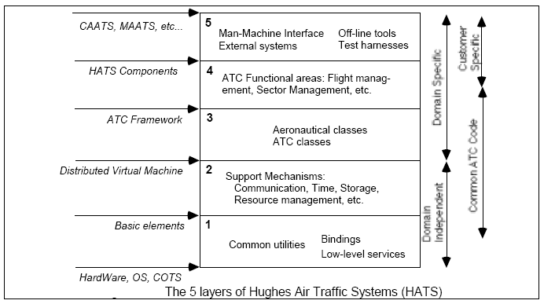

Software Dependencies
At a high-level, describe software upon which this design depends. If applicable, reference other features which are being done in parallel to support a larger project or other features which may have impact due to interactions or known changes in the same software being changed by this feature.

Party Component Description
If your design includes the use of third party software, document build versus buy analysis and rationale for the decision around adoption of this approach and describe how it will be integrated into the rest of the design.
Please note that we should be strongly encouraging use of existing software in order to avoid licensing costs incurred as a result of using 3rd party S/W.

Process Architecture
<This section is optional>
This is equivalent to the Process View as per the 4+1 model.
At a high-level, describe the process architecture required to satisfy the functional requirements. Identify new tasks or processes needed and/or changes to existing tasks to support the necessary execution flows.
If the design is within a single task or process and/or is completely task unaware, simply state this.
Sample:
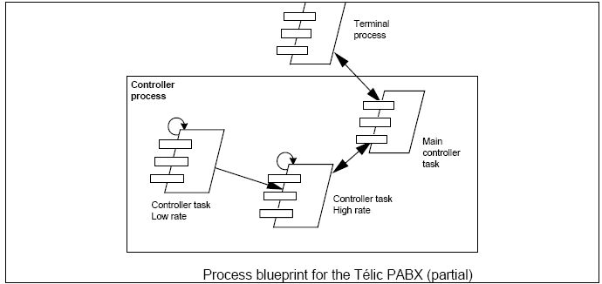

Deployment Architecture
<This section is optional>
This is equivalent to the Deployment View as per the 4+1 model.
At a high-level, map the software components to the hardware which will be used to deliver the functional requirements.
If the functional requirements are contained within a single hardware element or unaware of hardware, simply state this.
Sample:
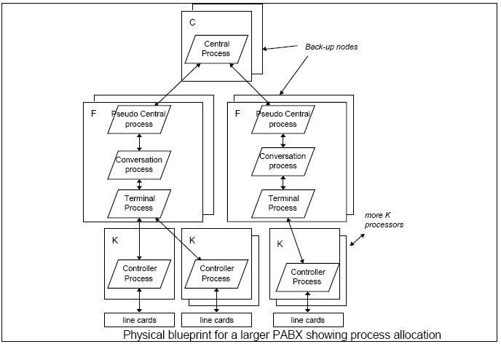

Detailed Design (Component Design)

<This section and its subsections specify internal details of components/modules. They also design algorithms, data types, and data structures for components and interfaces>
<Typical activities include
- Allocate all software requirements to modules
- Select algorithms, data types, and data structures for modules
- Specify data types for module interfaces
>

Component/Feature: <Component/Feature #1 (Use the name)>
<Supply a detailed description of the constituent classes of each component. List the important attributes of each class, and describe the purpose and processing of each major method within each class. Suitable UML diagrams should be provided to illustrate the relationships between each class within the component and any interactions between classes within separate components>

Object Model
<This subsection includes the class diagram required for this component.
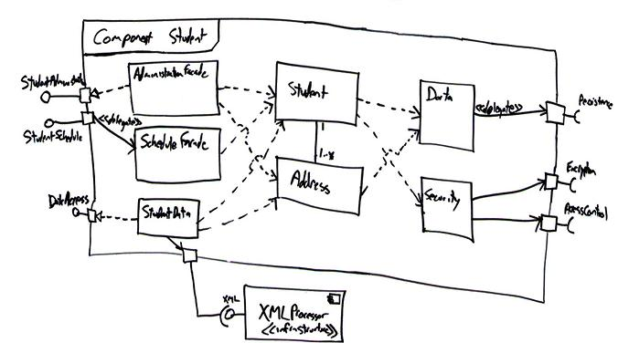
>

Scenarios
<This subsection includes the scenarios relevant to the design of this component but at the next level of detail.
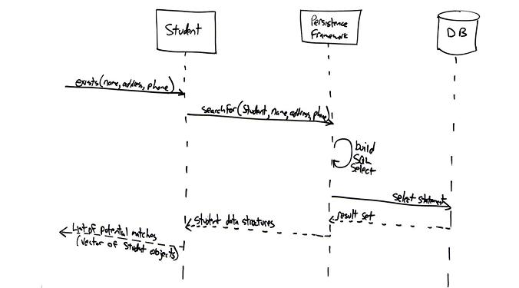
>

Class Summary
<This subsection includes a complete description of each class: methods, attributes, operations. Also, for a class which already exists, highlight here the changes made. ><Repeat for each class>

Class: <Class#1 (Use the class name)>

Attributes: | <(Data elements/variables)>
<Method #1 (Use the method name)> | <  - Pre-condition:  <List any assumptions that must be true in order for Component 1 to operate correctly. A good example is that Component 1 may assume that certain files are open or that a certain Internet connection has been established.>  - Post-condition:  <Describe the changes to the state of the system that have occurred as a result of the execution of this module. Note: This is the "what" requirement of the module.>  - Algorithm:  <List the steps (pseudocode, perhaps) taken by this component to achieve its intended purpose.>  - Error handling/Exception processing:  <Describe any error processing that is not made clear in the description of the algorithm.>  >
<Method #2> | <  - Pre-condition:  <List any assumptions that must be true in order for Component 1 to operate correctly. A good example is that Component 1 may assume that certain files are open or that a certain Internet connection has been established.>  - Post-condition:  <Describe the changes to the state of the system that have occurred as a result of the execution of this module. Note: This is the "what" requirement of the module.>  - Algorithm:  <List the steps (pseudocode, perhaps) taken by this component to achieve its intended purpose.>  - Error handling/Exception processing:  <Describe any error processing that is not made clear in the description of the algorithm.>  >
… | …

Algorithms
<Include a description of the designed algorithms>

Interfaces
<Include a description of the coding unit interfaces >

Dependencies
<Identify and describe the nature of dependencies upon other components of this design or other areas of the architecture in which this feature will reside>

Error Handling
<Include any debug commands, settings to enable extended debugging information, error messages and log files associated with this component. >

GUI Mockups
<Include any screen layouts or user interface mockups for this component.>

Open Issues
<List out any open issues herein>
---------- End of Document ----------

